Ideation Phase
Empathize & Discover

Date | 29 June 2026
Name | VARSHINI S
Project Name | The Metro Ticket Generating System automates the ServiceNow
Maximum Marks | 4 Marks

Empathy Map Canvas:
The users of the Metro Ticket Generating System are daily commuters who need a fast, secure, and convenient way to book metro tickets online. They expect a simple interface where they can select the source and destination stations, choose the journey type, enter passenger details, and receive a digital ticket with a QR code instantly.
Users want the ticket booking process to be quick, accurate, and available anytime without standing in long queues. They expect transparent fare calculation, instant booking confirmation, and the ability to track their request status. They also prefer receiving notifications throughout the booking process.
Users may feel frustrated when ticket booking is delayed, fare information is unclear, or manual processes require them to wait at ticket counters. They need an automated system that provides accurate fare calculation, secure data storage, QR code generation, and real-time booking updates.
The Metro Ticket Generating System in ServiceNow addresses these challenges by automating ticket booking through the Service Portal, validating user inputs, calculating fares, generating QR code tickets, storing booking details in a custom table, and executing the complete workflow using Flow Designer. This improves booking efficiency, reduces waiting time, enhances transparency, and provides a seamless travel experience for metro passengers.
Example:
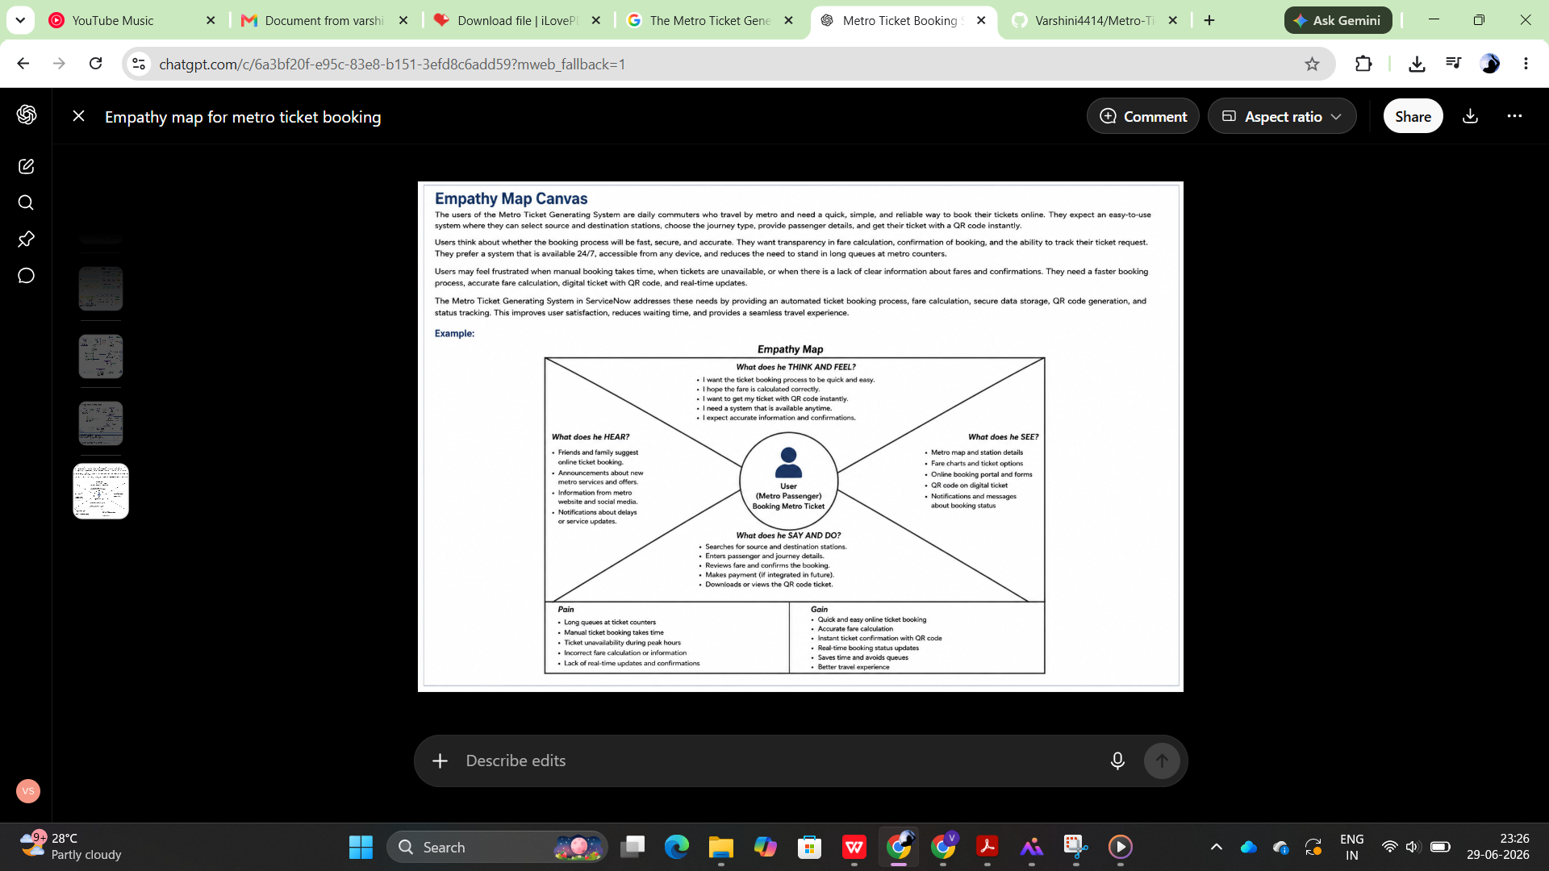

 | I THINK & FEEL |  | I SEE
 | • I want to book my metro ticket quickly. |  | • Metro booking portal with easy navigation.
 | • I expect the fare to be calculated correctly. |  | • Source and destination station list.
 | • I need my QR ticket instantly after booking. |  | • QR code displayed after successful booking.
 | • I want my booking to be secure and reliable. |  | • Booking confirmation and request status.
 | • I prefer a simple and user-friendly system. |  | • Notifications and booking updates.
I HEAR |  | I SAY & DO
• Friends recommend online metro booking. |  | • Opens the Service Portal.
• Metro announcements encourage digital tickets. |  | • Selects source and destination stations.
• Updates about new metro services. |  | • Chooses journey type and passenger count.
• Notifications about service changes. |  | • Reviews fare and submits booking.
• Information from metro authorities. |  | • Downloads or shows the QR ticket while travelling.

